**St**u**d**e**nt's Name..........................................................................................................**

**Signature .....................................................Personal Number................................**

***(Do not write your school, or Center Number anywhere on this booklet)***

**840/1**

**COMPUTER STUDIES**

**Paper 1**

 **June 2019**

21/2 hours

**EQUATORIAL COLLEGE - SCHOOL**

**Uganda Certificate of Education**

COMPUTER STUDIES

**Paper 1**

2 hours 30 minutes

**INSTRUCTIONS TO ST**U**D**E**NTS:**

*Write your names, signature, Personal Number in the spaces above.*

*This paper consists of* **three** *Sections* **A, B** *and* **C**

*Section* **A** *contains* **20 compulsory** *objective type questions. The correct alternative* **A, B, C** *or* **D** *must be written in the box provided on the right hand side of each question.*

*Section* **B** *contains* **six compulsory** *structured questions. Answers to section* **B****must** *be written in the spaces provided in the question paper.*

*Section* **C** *contains* **three** *essay questions. Answer only* **one***. Answers to section* **C** *must be written in the answer sheet provided.*

*Any additional question(s) answered will* **not** *be marked.*

**For Examiners' Use Only**

|  |  |  |  |  |  |  |  |  |
| --- | --- | --- | --- | --- | --- | --- | --- | --- |
| **MCQ** | **Q21** | **Q22** | **Q23** | **Q24** | **Q25** | **Q26** | **SEC: C** | **TOTAL** |
|  |  |  |  |  |  |  |  | **Turn Over** |

**SECTION A (20 MARKS)**

***Attempt all questions in this section***

1. Which one of the following tools would be the best for cleaning the outer surface of a monitor?
2. Dust blower
3. Form cleaner
4. Pliers
5. Screw driver.
6. At what stage of the following stages would flow charts be used in the programming process?
7. Testing stage
8. Design stage
9. Program coding stage.
10. Implementation stage.
11. Computer errors reporting to the user is a preserved function of…………………………….
12. Application software platforms
13. Operating system software
14. System utilities
15. Network administrator.
16. Which one of the following memory units is usually provided in system peripheral units?
17. Buffer memory
18. Cache memory
19. BIOS
20. Virtual memory.
21. Which one of the following roles is the main function of a software interface?
22. Storage of information
23. Enable the user to interact well with the software
24. Warning the user in cases of danger
25. Outputting data
26. The computer system maintains it configurations like date and time right even when the system is switched off from the main power source because of its?
27. CMOS
28. RAM
29. Automation
30. CMOS battery
31. A single structure representing a set of related data in a database table is referred to as…..
32. Field
33. Report
34. Record
35. Query
36. The standard protocol for Internet related electronic mails is…………….
37. TCP/IP
38. OSI
39. SMTP
40. NOS
41. Which one of the following data transmission media would offer a user the least data through-put?
42. Twisted pair
43. Optical fiber
44. Coaxial
45. Microwave
46. An active cell of a spreadsheet can easily be identified by?
47. Name box
48. Formulae bar
49. Worksheet tab
50. Worksheet charts
51. Which one of the following document processors is a word processor engine?
52. Note pad
53. Word wrap
54. WordPad
55. Lotus
56. The power-on self-test (*POST*) is run by…
57. BIOS.
58. Operating system
59. Log-on
60. Boot strap loader.
61. ……………………is a web page that allows users to make adjustments in the content previously uploaded.
62. Blog
63. Wiki
64. Aggregator
65. News group
66. Which one of the following statements is true about data values when they appear in a spreadsheet cell?
67. They are dressed in inverted quotation marks in logical functions
68. They usually left aligned by default
69. They are usually followed by a comma
70. They are usually right aligned in a cell by default
71. Which one of the following is not a navigation tool of slides during a presentation
72. Hyperlink
73. Action button
74. Remote sensor
75. Slide master
76. Which one of the following word processor proof reading tools would enable a user to quickly replace some words in a document with other words?
77. Autocorrect
78. Autocomplete
79. Spelling and grammar checker
80. Thesaurus
81. Which one of the following measures would ensure that changes made on the parent’s table are reflected on the child table?
82. Entity integrity
83. Referential integrity
84. Validity integrity
85. Primary key
86. When computers are classified as digital or analog it means that they are being classified basing on…….
87. Physical size
88. Specialty
89. Process
90. Processor power
91. In the mechanical era computers used ………………………………….. for their internal operations.
92. Integrated circuits
93. Diodes
94. Vacuum tubes
95. Gears
96. Which one of the following utilities would one use to prepare a storage media for data storage?
97. Formatting
98. Debugging
99. Anti-virus
100. Backup

**SECTION B**

***Attempt all questions in this section***

1. (a) (i) state **one** difference between a micro-computer and a mini-computer. ***(02 marks)***

(ii) List ***two*** characteristics of personal computers. ***(02 marks)***

(b) Give ***two*** examples of Hybrid Computers ***(02 marks)***

(c) State ***four*** challenges facing computer related jobs in Uganda ***(04 marks)***

1. (a) State ***three*** classifications of computer hardware ***(03 marks)***

(b) Give ***one*** difference between solid state and optical storage media ***(02 marks)***

(c) State ***two*** circumstances that can lead to re-installation of the operating system.

***(02 marks)***

(d) Give **three** situations that can necessitate one to warm boot a computer. ***(03 marks)***

1. (a) Name ***two*** situations where electronic spreadsheet application software can be used in a shop. ***(02 marks)***

(b) Give ***two*** situations that can necessitate one to use equal signs in an electronic spreadsheet cell. ***(02 marks)***

(c) Give ***two*** tools used for ensuring data integrity in electronic databases applications. ***(02 marks)***

(d) Explain the following electronic database concepts.

(i) **Field properties** ***(02 marks)***

(ii) **Data types** ***(02 marks)***

1. (a) With the help of an example briefly explain the concept of ***noise*** in electronic data transmission. ***(02 marks)***

(b) Briefly describe the meaning of the following terms as used in electronic data communication

(i) **Wi-Fi *(02 marks)***

**(ii) Bluetooth technology *(02 marks)***

(c ) State ***two*** features of an electronic web page ***(02 marks)***

(d ) Explain the following tags as used in web designing.

(i ) The **<title>** tag ***(01 mark)***

( ii ) The **<body>** tag ***(01 mark)***

1. (a) (i) Briefly describe the concept of **document referencing** as applied in electronic word processors. ***(02 marks)***

(ii) Give ***two*** examples of document referencing features found in electronic word processors. ***(02 marks)***

(b) Name ***two*** electronic presentation features used to navigate slides during a presentation ***(02 marks)***

(c) Give ***two*** publications that can be created using DTP software (***02 marks)***

(d) State ***two*** end product documents of a mail merge. ***(02 marks)***

1. (a) With the help of an *example* *define* computer utility software. ***(02 marks)***

1. State ***two*** characteristics of computer software. ***(02 marks)***
2. State ***two*** categories of programming language translators. ***(02 marks)***
3. Re-arrange the following programming stages in their ascending order.

**Coding & code review/documentation/Planning/analysis and design** ***(02 marks)***

1. Write a pseudocode for a program that would be used to solve equation: **E = MC2**. **(02 marks)**

**SECTION C**

**(Attempt *only one* Question from this section)**

1. **(a)** Assuming that you have been provided with the following tools; anti-virus utility tools kit, five CCTv cameras, cable seals, Alarm alert devices, device engraving tool, burglar proof set, ten automatic security lights, G7 model Firewalls kit, and a security guard. Demonstrate how you would use the above mentioned tools to enhance computer systems security. ***(09 marks)***

**(b)** State ***five*** challenges facing computer software in your school. ***(05 marks)***

**(c)** Using examples, describe any ***six*** advanced technologies which show the growth of information technology in your country. ***(06 marks)***

1. (a) Define a flow chart as used in programming. ***(02 marks)***

(b) Explain the types of flow charts. ***(04 marks)***

(c)In an Olympics track event, medals are awarded only to the first three athletes as follows:

* *Position 1: Gold medal*
* *Position 2: Silver medal*
* *Position 3: Bronze medal*

Write pseudocode, flowchart and using C or VB language write a Code for the above program. ***(14 marks)***

1. (a) An organization needs to open businesses such that **ROUTER 1** is located at Mbale town, **ROUTER 2** at Jinja Town, **ROUTER 3** at Kampala City and ROUTER 4 at Mbarara town for easy manageability. Study the network topology in Figure 1 and answer the following questions:

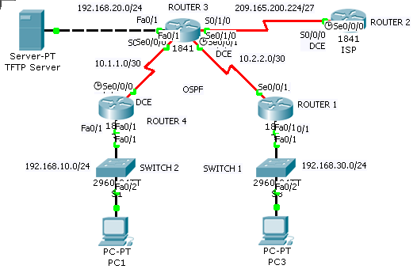

1. State the number(s) of Wide Area Network in this topology. ***(01 mark)***
2. How many Local Area Network(s) is/are presented in the topology? ***(01 mark)***
3. How many network devices are in this topology? ***(01 mark)***
4. How many end users devices are in this network? ***(01 mark)***
5. What type of physical topology is exhibited in this network? ***(01 mark)***

(b) You are given a task of assembling a computer system. Use the following procedure to arrange your **five** steps chronologically. ***(05 marks)***

* Connect the external cables to the ports on the back of the computer.
* Connect all internal cables to the appropriate computer components.
* Attach the power supply to the case.
* Install the RAM, CPU, Thermal compound and Heat sink on the motherboard and screw the motherboard on the system case.
* Connect the adapter cards, internal drives such as HDD, CR-RW/DVD and FDD drives in external bays.

(b) Study the following diagram of components in a computer system unit and answer the questions that follow:

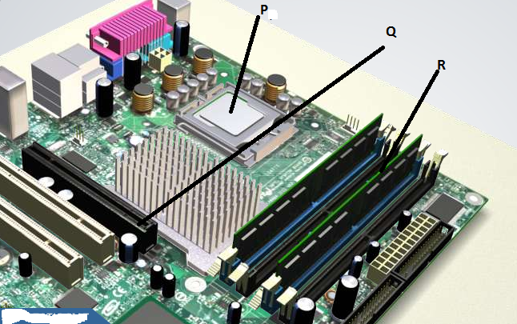

1. Give the ICT name for the parts labeled, P, Q and R. ***(03 marks)***
2. Study and state the main function of parts labeled, P and R. ***(02 marks)***
3. A **USB port** can connect up to 127 different peripherals together with a single connector. State where USB port type B are used. ***(03 marks)***

**END**